

**An interactive robotic system through voice commands**

**A project report submitted in partial fulfillment of the**

**requirement for the award of the degree of**

**Bachelor of Computer Science**

**By**

**Mohmmed Ibrahim Fallath**

**Bandar Abdullelah Hakami**

**Supervised By**

**Dr. Tareq A. Alhmiedat**

**Department of Computer Science**

**Faculty of Computers and Information Technology**

**University of Tabuk**

**2017**

**DECLARATION**

I hereby declare that this project report is based on my original work except for citations and quotations which have been duly acknowledged. I also declare that it has not been previously and concurrently submitted for any other degree or award at University of Tabuk or other institutions.

Date: _________________________

Signature: _______________________

**APPROVAL FOR SUBMISSION**

I certify that this project report entitled **" An interactive robotic system through voice commands "** was prepared by Mohammed and Bandar , has met the required standard for submission in partial fulfillment of the requirements for the award of Bachelor of Computer Science at the University of Tabuk.

Approved by,

Signature : _________________________

Supervisor : **Dr. Tareq Alhmiedat**

Date : _________________________

**COPYRIGHT**

The copyright of this report belongs to the author and is protected under the intellectual property right laws and conventions. It can only be considered/used for purposes like extension for further enhancement, product development, adoption for commercial/organizational usage, etc., with the permission of the author.

© 2016, Tabuk university . All right reserved

**ACKNOWLEDGEMENTS**

I would like to thank everyone who had contributed to the successful completion of this project. I would like to express my gratitude to my research supervisor, **Dr. Tareq A. Alhmiedat** for his invaluable advice, guidance and his enormous patience throughout the development of the research.

**ABSTRACT**

Visually impaired and elder people have some difficulties interacting with computer-based systems including robotics using the traditional user interface methods (remote control, keyboards, mouse, ….) however these difficulties can be overcome through employing a voice command interactive system, an efficient component robotic system, is the voice command function which helps the robot to listen, understand, and behaves accordingly. The main aim for this project is to operate the robotic vehicle based on two-way voice commands. The user may interact with the robotic system through voice commands. whereas the robotic system may respond to the user command through voice command, therefore, the robotic system needs to listen and understand the user commands and behaves accordingly.

**Table of Content**

DECLARATION 2

APPROVAL FOR SUBMISSION 3

COPYRIGHT 4

ACKNOWLEDGEMENTS 5

ABSTRACT 6

Table of Content 7

Chapter content 8

List of Figures 9

List of Tables 10

LIST OF ABBREVIATIONS 11

**Chapter content**

CHAPTER ONE 12

INTRODUCTION 12

1.1 Background 12

1.2 Problem Overview: 12

1.3 Project Concept 13

1.4 Aims and Objectives 13

CHAPTER 2 13

RELATED WORKS 14

2.1 Introduction 14

2.2 Related works 14

CHAPTER 3 15

METHODOLOGY AND DESIGN 16

3.1 Introduction 16

3.2 Agile Software Development 16

3.3 Why using CBSE? 16

3.4 Development process in CBSE: 16

3.5 CBSE system development process: 16

3.6 Main Requirement (Main User Story) 17

3.7 Design 18

3.7.1 Version #1.0 18

34

Chapter 4 39

SYSTEM IMPLEMENTATION 39

4.1 Introduction 39

4.2 Main Functionalities 39

And we will discuss each one in the next sections 39

4.3 manual controlling 39

4.4 voice controlling 39

4.5 Free Drive 40

4.6 System Implementation 41

Chapter 5 44

CONCLUSION AND FUTURE WORKS 44

REFERENCES 45

**List of Figures**

Figure 1.1 Project concept 13

Figure 3-1: V#1.0 Use Case Diagram 18

Figure 3-2: Domain Diagram 25

Figure 3-3Class Diagram 26

Figure 3-4Sequence Diagram For Activate Use Case 27

Figure 3-5Sequence Diagram for DeActivate Use Case 28

Figure 3-6Sequence Diagram For manual controlling Use Case 29

Figure 3-7: Sequence Diagram For activate speech recognition Use Case 30

Figure 3-8 Sequence Diagram For deactivate speech recognition use Case 31

Figure 3-9 Sequence Diagram For voice controlling use Case 32

Figure 3-10Activity Diagram For activate Use Case 33

Figure 3-11Activity Diagram For deactivate Use Case 34

Figure 3-12Activity Diagram For manual controlling Use Case 35

Figure 3-13Activity Diagram For activate speech recognition Use Case 36

Figure 3-14Activity Diagram For deactivate speech recognition Use Case 37

Figure 3-15Activity Diagram For voice controlling Use Case 38

Figure 4- 1 Infrared sensor for distance measurement 41

Figure 4- 2: Main Graphical User Interface 42

figure 4 - 3 voice control Graphical user Interface 43

fegur 4 - 4 Manual control Graphical user Interface 44

**List of Tables**

**Table 3 - 1 activate Use Case Description** 18

**Table 3 - 2 activate Use Case Description** 19

**Table 3 - 3: manual controlling** 20

**Table 3 - 4:activate speech recognition** 21

**Table 3 - 5: deactivate speech recognition Use Case Description** 22

**Table 3 - 6voice controlling Use Case Description** 23

**LIST OF ABBREVIATIONS**

|  |  |
| --- | --- |
| XP | Extreme programming |
| CBSE | Component Based Software Engineering |
| PC | Personal Computer |

**CHAPTER ONE**

INTRODUCTION

2. Background

Robots are a package of systems which include mechanical, electrical, computing and automation fields of technology which can be used to perform various tasks in industrial and domestic use. And with increasing developments in this field robots can now be controlled with lesser direct human intervention to achieve a more natural interaction with machines. A way to accomplish such is to control a robot via voice commands. This allows the user to free up their hands and work on other tasks. Some basic applications of robots utilizing voice recognition are to support people with disability, executing preset commands etc. [1].

Voice controlled robotic systems use signals to control robotic systems. These robots have enormous applications in numerous fields ranging from medicine such as wheel chair control by disabled patients to industrial machinery control.

1.2 Problem Overview:

Visually impaired and elder people have some difficulties interacting with computer-based systems including robotics using the traditional user interface methods (remote control, keyboards, mouse, ….). For instance, old people may have difficulties in using computers, and also they might have some problem in dealing with robotics using the traditional methods. Therefore, they must be an interactive way for communicating with robots.

1.3 Project Concept

The main concept of this project is to control a robot with voice commands. The robot is able to recognize voice commands to move correctly. For example, the robot’s movement can be controlled by a certain voice command. In our project, the voice commands are captured by a microphone attached to a personal computer, where a voice command algorithm is implemented there. As soon as the voice command is processed and analyzed, Wi-Fi signals will be transmitted to the robotic system in order to control the direction according to the voice command issued by the user. Figure 1.1 presents the project main concept.

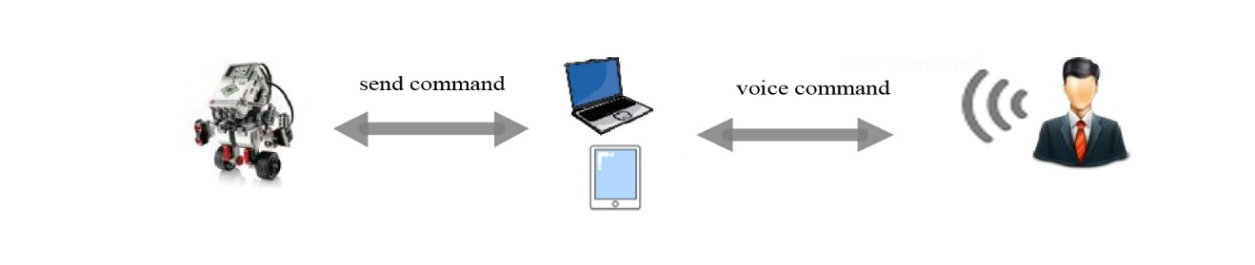

Figure 1.1 Project concept

## 1.4 Aims and Objectives

The main aim for this project is to operate the robotic vehicle based on two-way voice commands. The specific objectives associated with achieving the project aim are as follows:

* Research the existing systems to obtain better understanding of the topic.
* Design and implement a robotic system using Lego EV3 platform.
* Design and implement Voice Controlled system to monitor and control the designed robotic system.
* Test the efficiency of designed localization algorithm using Lego EV3 robot kit.

**CHAPTER 2**

RELATED WORKS



2.1 Introduction

This project aims to design and implement a voice-recognition robotic system, where the user can control and monitor the robotic system through voice-commands. In this section, we discuss the most relevant systems.

2.2 Related works

Voice-command robotic systems are divided into two main parts: the speech recognition system, and the robotic system. The work presented in [2] presents a speech-control robotic system, which has the ability to control robotic system using speech recognition techniques. The implemented system is efficient in terms of real-time operations. The designed system consists of two main components: the robotic system and the base-station, and they are connected through WLAN.

Another system presented in [3], where a voice recognition robotic system is designed and implemented using (VRCS) robotic system. The implemented system can robustly recognize the voice by adults and children in noisy environment. The work tested using real-time wireless microphone and robotic system. In this work, all experiments were performed in noisy environments.

In [4], authors proposed an integrated robust voice recognition and navigation system capable of performing autonomous navigation in unknown environments. The experimental results show that the voice recognition mobile robotic system can arrive at the goal destination according to the speaker desire. In this work, no available information about the experiment test-bed.

NavyChair [5] is an Assistive Wheelchair Navigation System which is being developed to provide mobility to those who find it difficult to use a powered wheelchair. NavyChair can navigate the user indoors. NavyChair prototype was tested using Lancer power wheelchair module. The implemented work consists of three main components: IBM computer, an array of sensors, and interactive module which provides the necessary circuit for the system.

The design and development of a powerful voice control robotic system is presented in [6]. The developed system consists of three modes of operational voice-recognition algorithms. The main goal of this work is the design of a universal intelligent control system that can be used easily by patients to control any electrical wheeled applications.

**2.3 Discussion**

As noticed above, there are a wide variety of proposed systems regarding the topic. We summarized the most important works. However, in order to develop such voice-robotic applications, there are a number of requirements which have to be taken into consideration:

First, the cost. Most of the existing developed systems [3, 4, 5] are high in cost, since there is a requirement for a PC to be installed in the project in order to perform voice recognition. In addition, to deploying expensive hardware design. Therefore, there is a requirement to minimize the cost for such applications using inexpensive hardware design.

Second, the efficiency of the voice recognition system. In order to perform reasonable controlling results. The developed voice recognition algorithm must be efficient in noisy environments, as the presented work in [3].

Third, the efficiency of the deployed robotic system. The designed robotic system must be easy to interact with, in order to preform operations in an efficient manner. For instance, easy to move and interact.

In conclusion, in order to design and implement an efficient voice-recognition robotic system, the aforementioned three metrics have to be taken into consideration.

# CHAPTER 3

**METHODOLOGY AND DESIGN**

1. Introduction

This chapter discusses the Agile methodology which used to build the system, and the main system user story and the user story and design for each version implemented.

1. Agile Software Development

We have used the XP style which seeded within the method of Agile software development, it is a fast way to develop software, not the way the traditional water fall that based on full analysis of the system before the beginning of its development. either way, the XP shall be the beginning of a very early stage of the code, which is split system development into several stages (Versions), and be the first stage in a simple and basic thing, and this stage including the basic features.

This method is highly recommended for developing real time systems like this one.

1. Why using CBSE?
   1. CBSE increases quality, especially evaluability and maintainability.
   2. CBSE increases productivity and shortness development time.
2. Development process in CBSE:
3. Development of components.
4. Development of system out of components.
5. Separate process to assess components
6. CBSE system development process:
7. Requirements (User Story): also considers availability of components.
8. Analysis and Design: very similar to what we normally do.
9. Implementation: less coding, focus on selection of components, provision of glue code.
10. Integration: largely automated.
11. Testing: verification of components is necessary.
12. Release: as in classical approaches.
13. Maintenance: replace components
14. Main User Story

Build an interactive robotic system through voice commands in wish the robot is able to recognize voice commands to move correctly. For example, the robot’s movement can be controlled by a certain voice command the voice commands are captured by a microphone attached to a personal computer, where a voice command algorithm is implemented there. As soon as the voice command is processed and analyzed, Wi-Fi signals will be transmitted to the robotic system in order to control the direction according to the voice command issued by the user.

Whenever the user like to interact with the system through voice command the system must do exactly what user say based in programmed function that can understand and interact with voice commands

The system should provide the ability to control the robot manually in case the voice system has programming issues or temporary connection fail , and try to fix the voice recognition problem as fast as possible.

1. Design
   * 1. Version #1.0

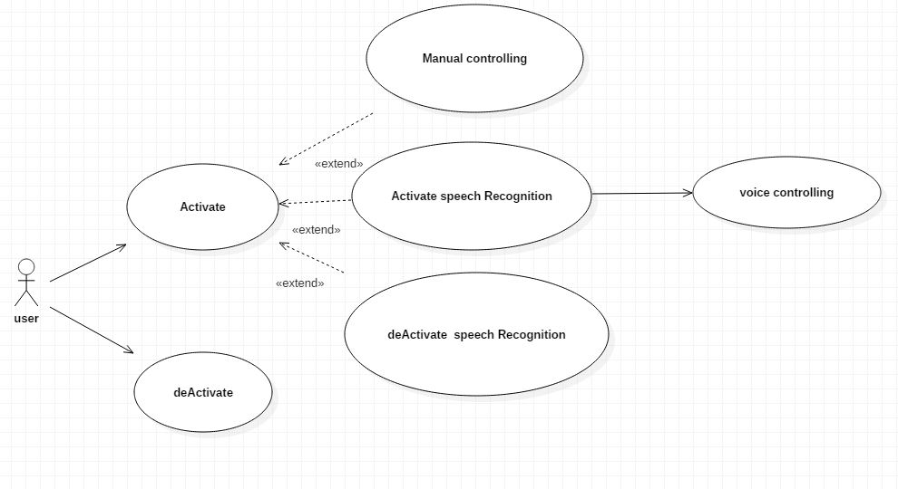Design and implement a prototype version of interactive robotic system through voice commands.

**Figure 3-1: V#1.0 Use Case Diagram**

|  |  |  |
| --- | --- | --- |
| **Use Case Name:** Activate | **ID:** 1 | **Importance Level:**  High |
| **Primary Actor:** user | **Use Case Type:** Essential | |
| **Stakeholders and Interests:**  Old people , people with disabilities. | | |
| **Brief Description:**  Activate the robot and establish connection. | | |
| **Trigger:** user.  **Type:** External | | |
| **Normal Flow of Events:**  Establishing the connection and activate all sensors. | | |
| **Sub Flows:**  S-1: Deactivate. | | |
| **Failure Flows:**  F-1: Connection Error.  F-2: Low Battery. | | |

**Table 3 - 1 activate Use Case Description**

|  |  |  |
| --- | --- | --- |
| **Use Case Name:** Deactivate | **ID:** 2 | **Importance Level:**  High |
| **Primary Actor:** user | **Use Case Type:** Essential | |
| **Stakeholders and Interests:**  Old people, people with disabilities. | | |
| **Brief Description:**  The user can Stop the connection and continue it any time | | |
| **Trigger:** user  **Type:** External | | |
| **Normal Flow of Events:**  The user stops the robot and stop the connection any time. | | |
| **Sub Flows:**  S-1: Keeps Moving. | | |
| **Failure Flows:**  F-1: Low Battery.  F-2: Connection Error. | | |

**Table 3 - 2 deactivate Use Case Description**

|  |  |  |
| --- | --- | --- |
| **Use Case Name:** manual controlling | **ID:** 1.1 | **Importance Level:**  High |
| **Primary Actor:** user | **Use Case Type:** Detail | |
| **Stakeholders and Interests:**  Old people , people with disabilities. | | |
| **Brief Description:**  The user can start driving the robot manually without need to use voice commands. | | |
| **Trigger:**  user  **Type:** Internal | | |
| **Normal Flow of Events:**  Control the robot and move it manually to selected direction . | | |
| **Sub Flows:**  S-1: Stop. | | |
| **Failure Flows:**  F-1: Low Battery.  F-2: motor Damage.  F-3: Infinite Loop.  F-4: Connection Error. | | |

**Table 3 - 3: manual controlling Use Case Description**

|  |  |  |
| --- | --- | --- |
| **Use Case Name:** activate speech recognition | **ID:** 1.1.1 | **Importance Level:**  High |
| **Primary Actor:** user | **Use Case Type:** Detail | |
| **Stakeholders and Interests:**  Old people, people with disabilities. | | |
| **Brief Description:**  The user can activate the voice recognition to interact with robot through voice  commands without need to move his hands. | | |
| **Trigger:**  user  **Type:** Internal | | |
| **Normal Flow of Events:**  The user activate the voice recognition at any time during system working. | | |
| **Sub Flows:**  S-1: deactivate speech recognition. | | |
| **Failure Flows:**  F-1: Low Battery.  F-2: Infinite Loop.  F-3: microphone Error. | | |

**Table 3 - 4:activate speech recognition Use Case Description**

|  |  |  |
| --- | --- | --- |
| **Use Case Name:** deactivate speech recognition | **ID:** 1.1.2 | **Importance Level:**  High |
| **Primary Actor:** user | **Use Case Type:** Detail | |
| **Stakeholders and Interests:**  Old people, people with disabilities. | | |
| **Brief Description:**  The user can deactivate the voice recognition and control the robot manually. | | |
| **Trigger:**  user  **Type:** Internal | | |
| **Normal Flow of Events:**  Control the robot manually and stop voice recognition option. | | |
| **Sub Flows:**  S-1: voice controlling | | |
| **Failure Flows:**  F-1: programming error. | | |

**Table 3 - 5: deactivate speech recognition Use Case Description**

|  |  |  |
| --- | --- | --- |
| **Use Case Name:** voice controlling | **ID:** 1.1.3 | **Importance Level:**  High |
| **Primary Actor:** user | **Use Case Type:** Detail | |
| **Stakeholders and Interests:**  Old people, people with disabilities. | | |
| **Brief Description:**  The user can control the robot through voice commands. | | |
| **Trigger:**  user  **Type:** Internal | | |
| **Normal Flow of Events:**  The robot will move according to given voice command. | | |
| **Sub Flows:**  S-1: manual controlling. | | |
| **Failure Flows:**  F-1: microphone error.  F-2: motor damage.  F-3: connection lost. | | |

**Table 3 - 6voice controlling Use Case Description**

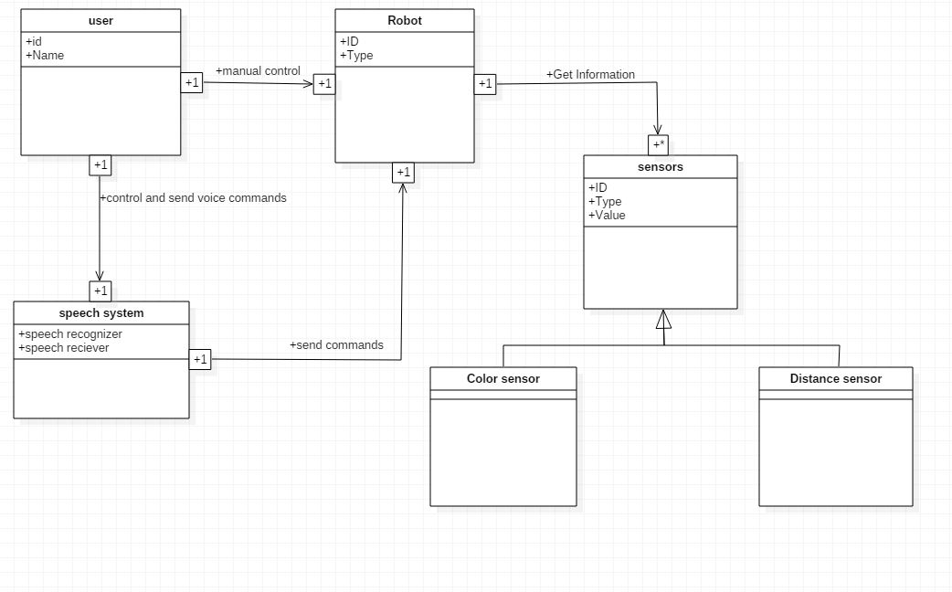

**Figure 3-2: Domain Diagram**

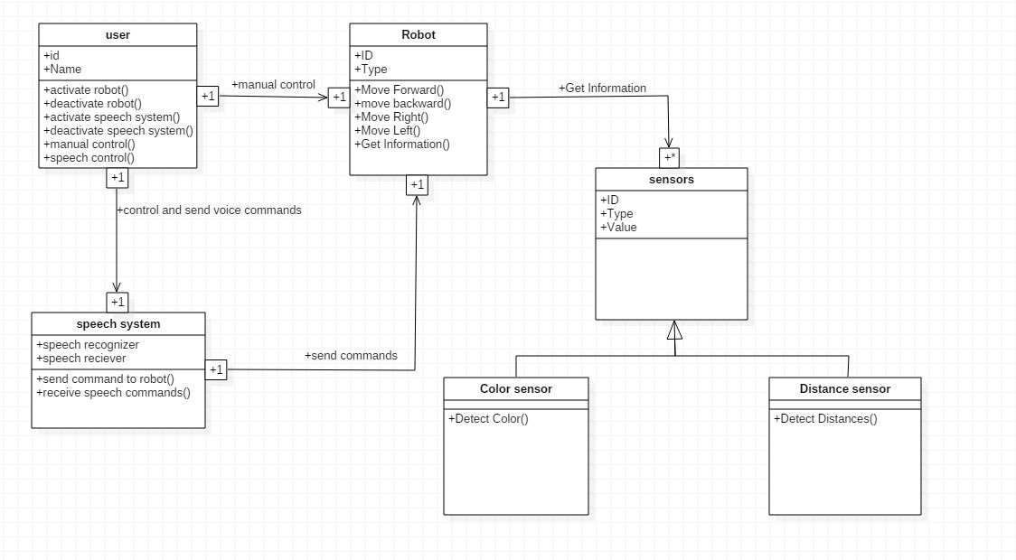

**Figure 3-3Class Diagram**

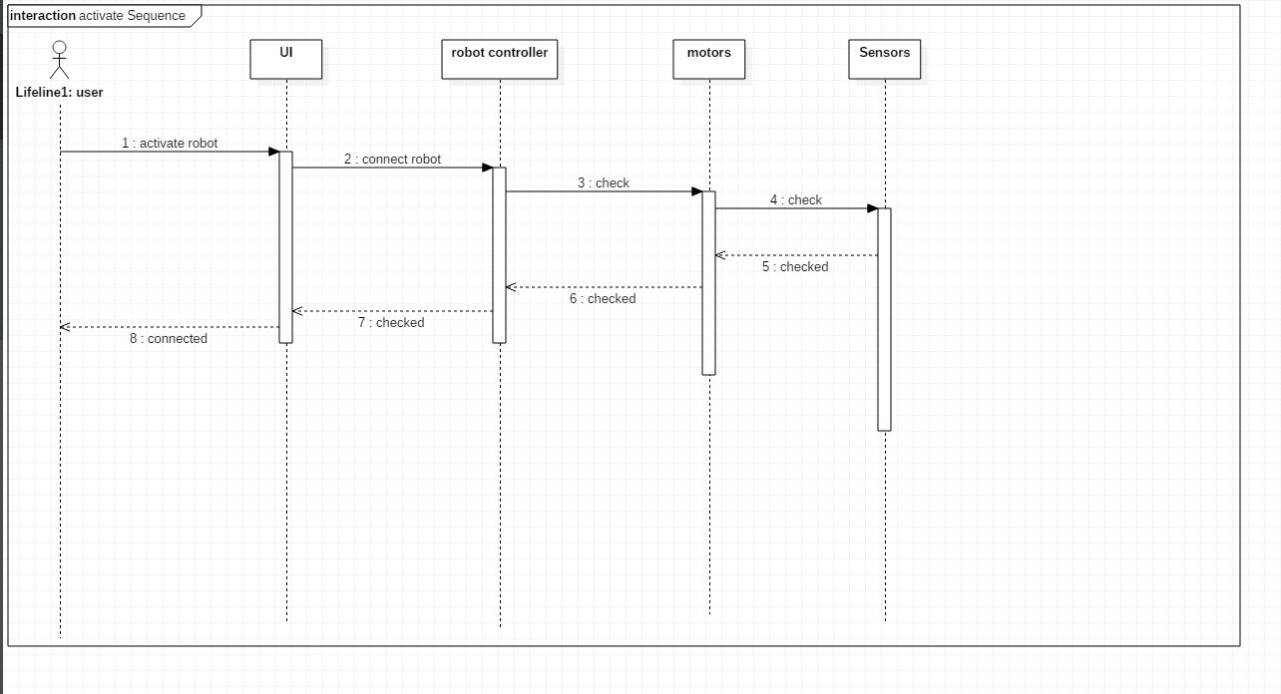

Figure 3-**4Sequence Diagram For Activate Use Case**

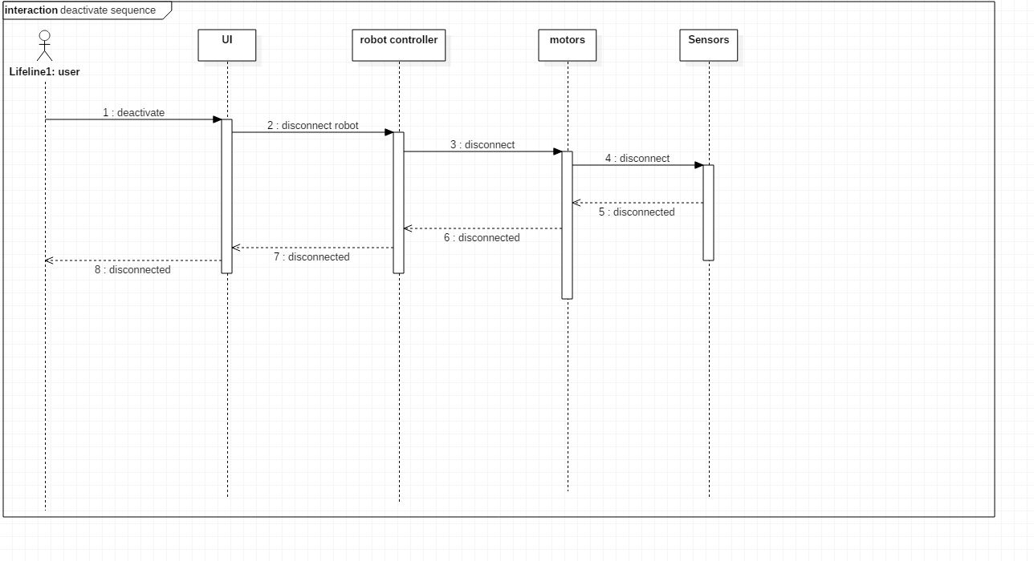

**Figure 3-5Sequence Diagram for DeActivate Use Case**

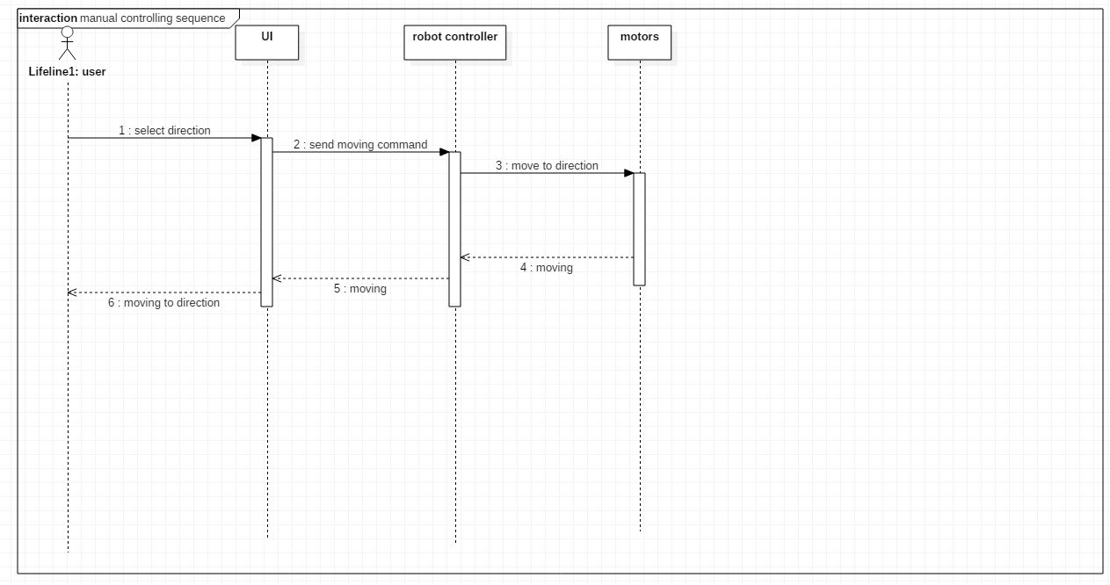

**Figure 3-6Sequence Diagram For manual controlling Use Case**

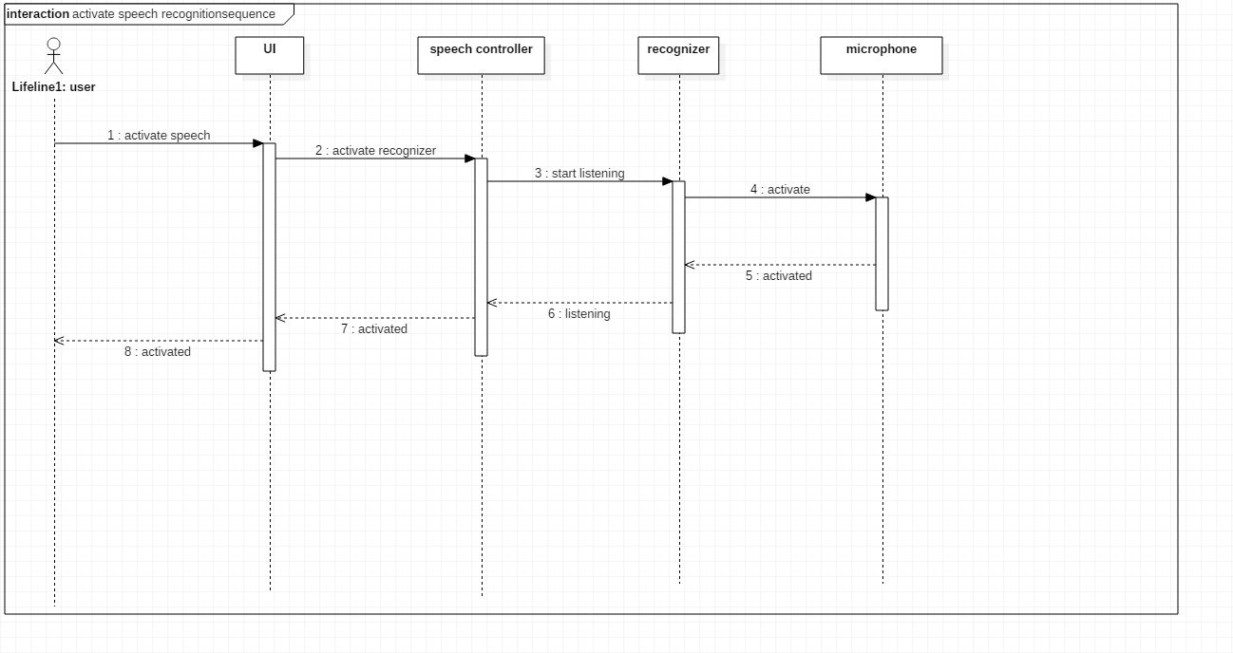

**Figure 3-7: Sequence Diagram For activate speech recognition Use Case**

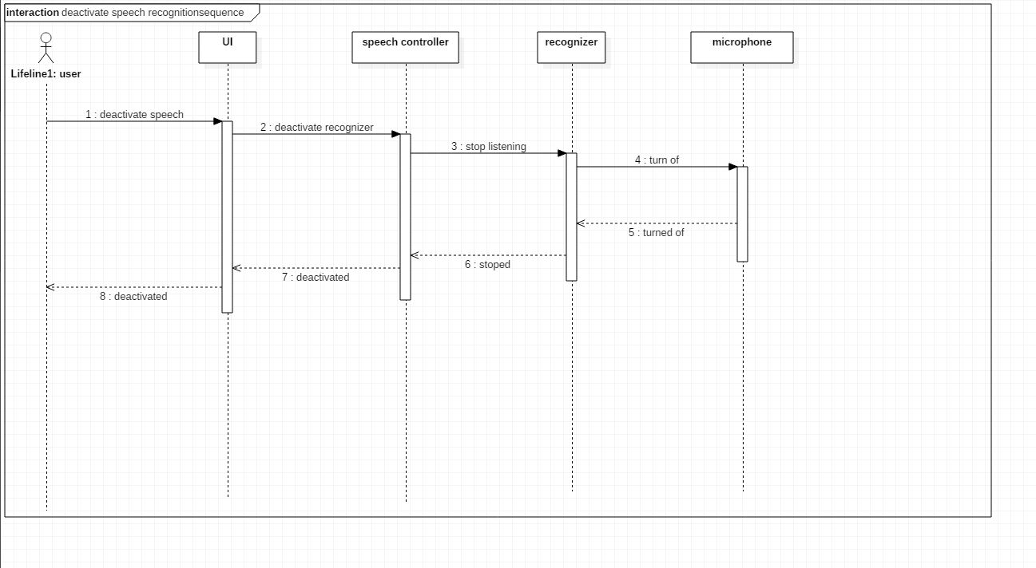

**Figure 3-8 Sequence Diagram For deactivate speech recognition use Case**

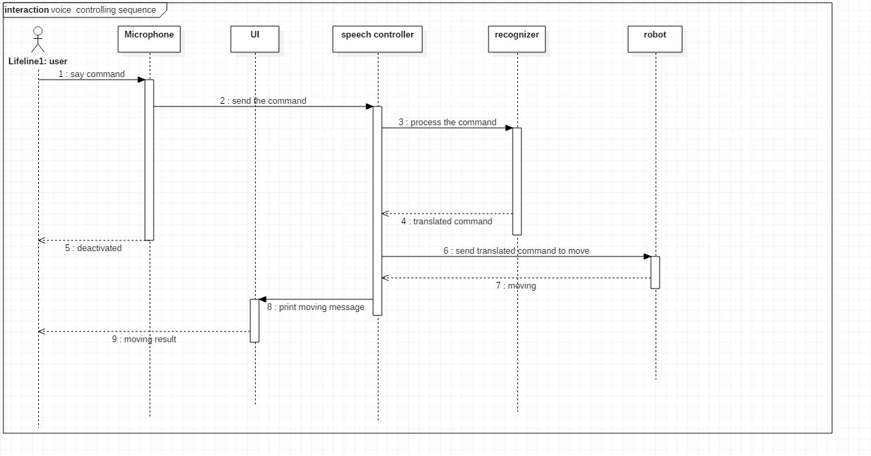

**Figure 3-9 Sequence Diagram For voice controlling use Case**

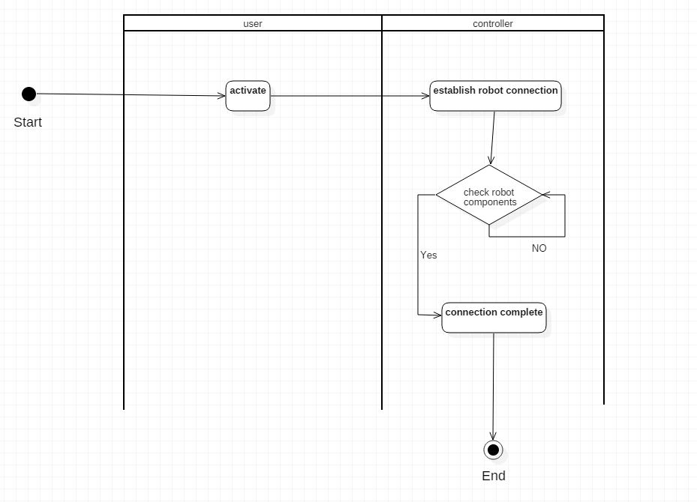

**Figure 3-10Activity Diagram For activate Use Case**

# C:\Users\MHD\AppData\Local\Microsoft\Windows\INetCache\Content.Word\deactivate activity diagram.jpg

**Figure 3-11Activity Diagram For deactivate Use Case**

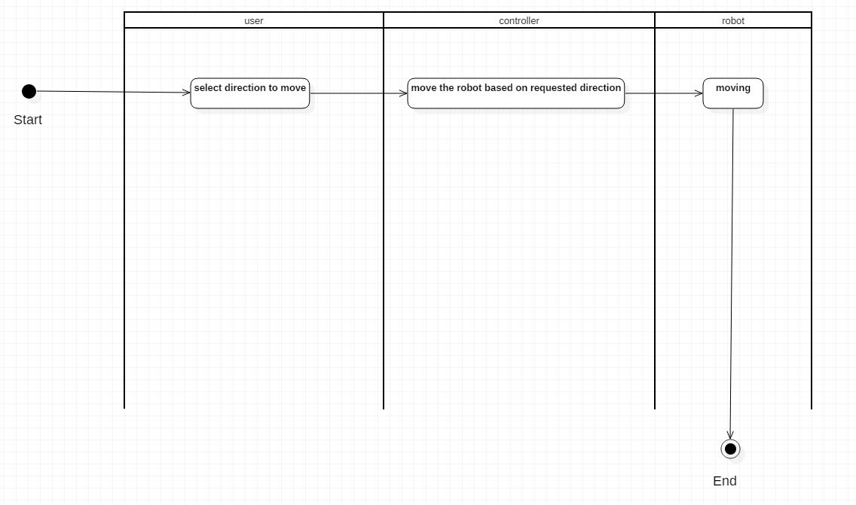

**Figure 3-12Activity Diagram For manual controlling Use Case**

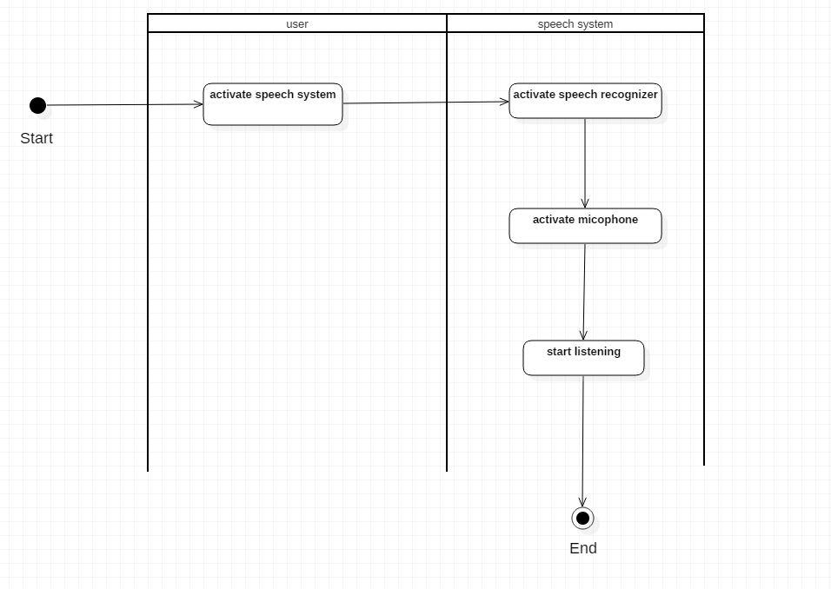

**Figure 3-13Activity Diagram For activate speech recognition Use Case**

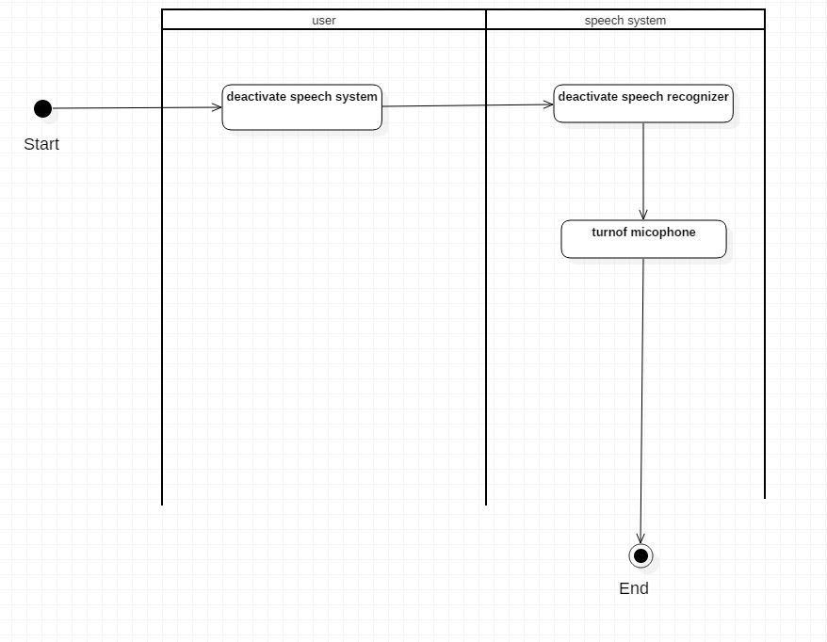

**Figure 3-14Activity Diagram For deactivate speech recognition Use Case**

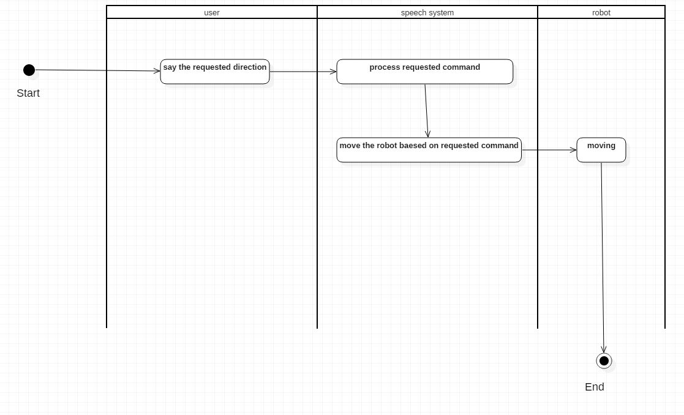

**Figure 3-15Activity Diagram For voice controlling Use Case**

Chapter 4

SYSTEM IMPLEMENTATION

4.1 Introduction

this Chapter, explain the system implementation of our application and it could be used as a system manual that guide the users to the best usage of our system. This chapter includes: main functionalities, system implementation.

**4.2 Main Functionalities**

The main functionalities which offered by the developed system are:

1. Manual Controlling
2. voice Controlling
3. Free Drive

And we will discuss each one in the next sections

4.3 manual controlling

The voice recognition system is also able to be controlled manually, which will allow the user to avoid any problems in case the voice recognition system is down for any reason and keep both the robot and the user safe. we will explain manual controlling steps later in this chapter

4.4 voice controlling

the main function of this system is to provide users the ability to control the robot by voice and allow them to interact with the system without even move their bodies.

Using the voice recognition library provided by Microsoft we were able to accomplished this goal. we will explain voice controlling steps later in this chapter

4.5 Free Drive

The robot will move automatically when this function is selected, the deigned robotic system has the feature of detecting the obstacles facing its way and adapts according to the given decision by the user, by keeping a safely distance between the robot and the obstacle heading it. Figure 4-1 presents the sensor used to measure the distance between the robot and heading object (wall, chair, …etc.).

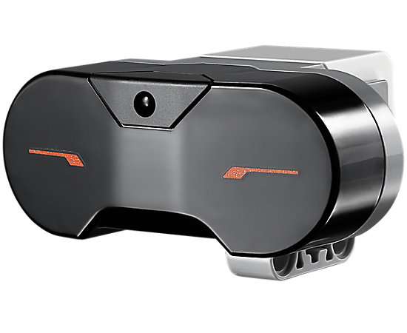

Figure 4- **1 Infrared sensor for distance measurement**

**4.6 System Implementation**

The designed work has been implemented using Visual Studio 2015: Visual studio is an Integrated Development Environment (IDE) from Microsoft. Visual studio is used to develop and implement computer programs for Microsoft Windows, in addition to websites, web applications, and web services.

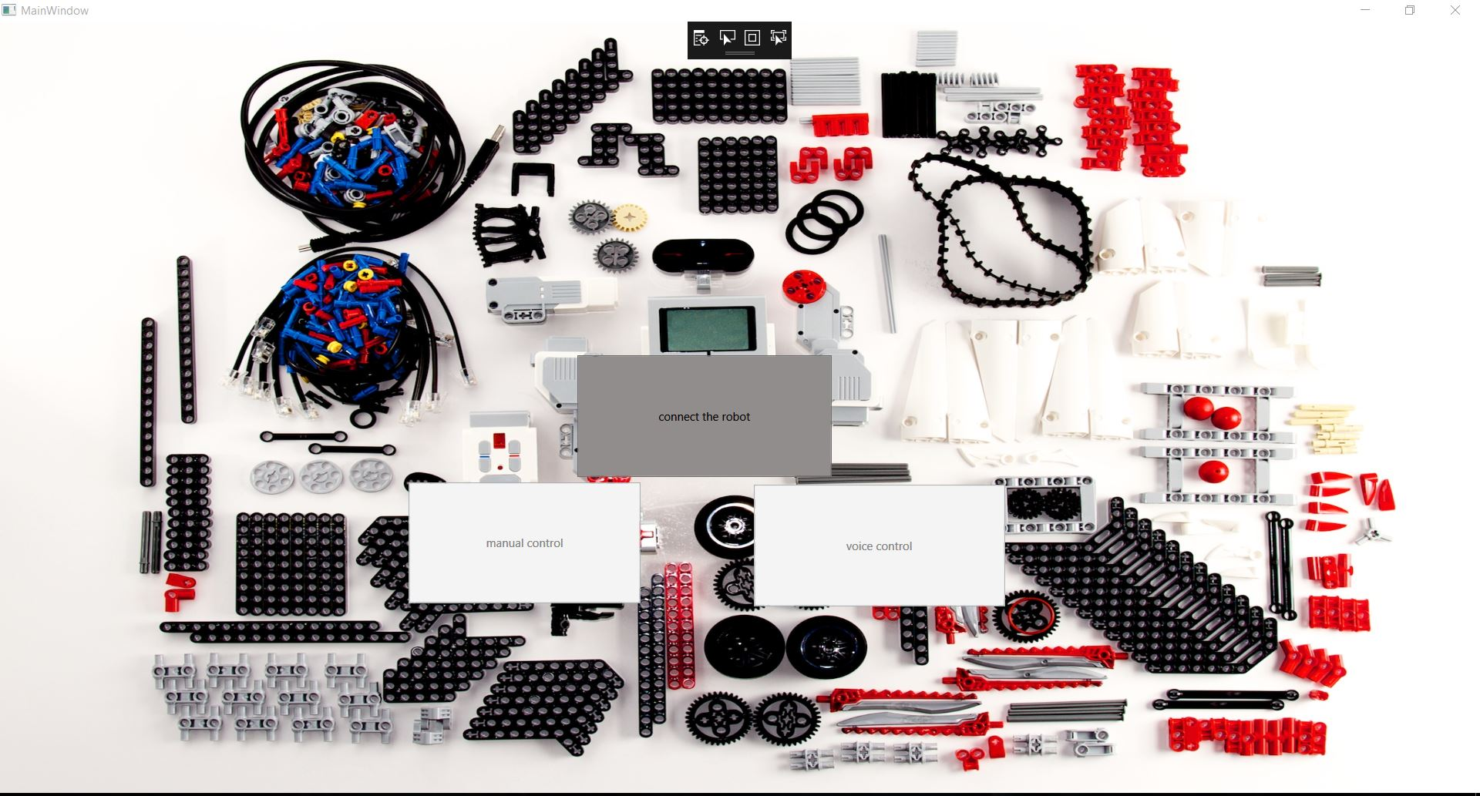

**Figure 4- 2: Main Graphical User Interface**

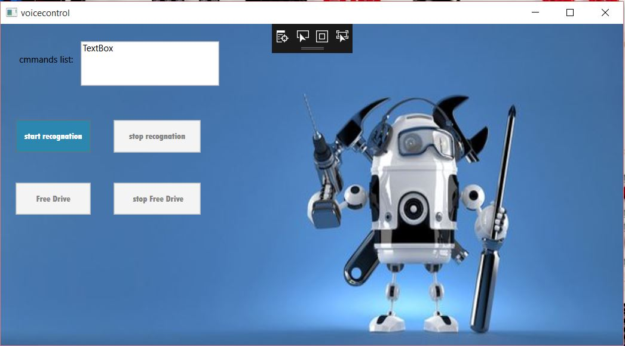

**figure 4 - 3 voice control Graphical user Interface**

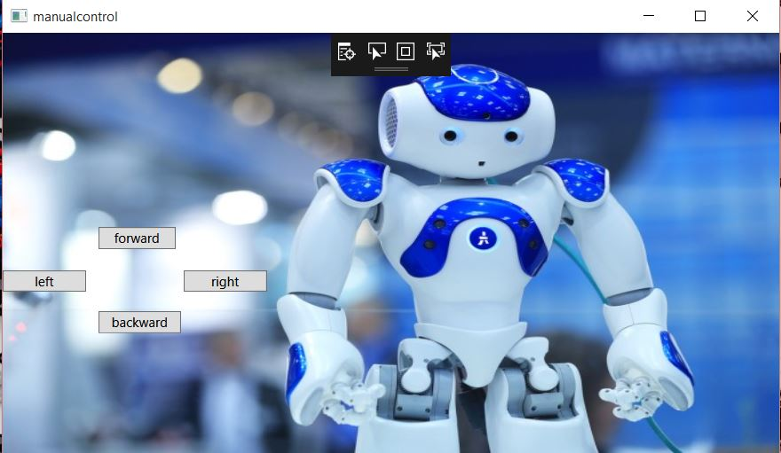

**Figure 4 - 4 Manual control Graphical user Interface**

# Chapter 5

CONCLUSION AND FUTURE WORKS

The main objective of this work was to design and implement a An interactive robotic system through voice commands using Lego Mindstorm EV3. We aim to design a voice commands robotic system which will be able to differentiate the users voices and act based on the privileges of each user.

REFERENCES

[1] Niku, S., 2010. *Introduction to robotics*. John Wiley & Sons.

[2] Lv, X., Zhang, M. and Li, H., 2008, September. Robot control based on voice command. In Automation and Logistics, 2008. ICAL 2008. IEEE International Conference on (pp. 2490-2494). IEEE.

[3] Shim, B.K., Kang, K.W., Lee, W.S., Won, J.B. and Han, S.H., 2012, October. An intelligent control of mobile robot based on voice command. In Control, Automation and Systems (ICCAS), 2012 12th International Conference on(pp. 1878-1881). IEEE.

[4] Shim, B.K., Cho, Y.K., Won, J.B. and Han, S.H., 2011, October. A study on real-time control of mobile robot with based on voice command. In Control, Automation and Systems (ICCAS), 2011 11th International Conference on(pp. 1102-1103). IEEE.

[5] Simpson, R.C., Levine, S.P., Bell, D.A., Jaros, L.A., Koren, Y. and Borenstein, J., 1998. NavChair: an assistive wheelchair navigation system with automatic adaptation. In Assistive technology and artificial intelligence (pp. 235-255). Springer, Berlin, Heidelberg.

[6] Ruzaij, M.F., Neubert, S., Stoll, N. and Thurow, K., 2016. Hybrid Voice Controller for Intelligent Wheelchair and Rehabilitation Robot Using Voice Recognition and Embedded Technologies. Journal of Advanced Computational Intelligence and Intelligent Informatics, 20(4), pp.615-622.